# A COMPREHENSIVE MEASURE OF WELL-BEING : THE HUMAN DEVELOPMENT INDEX

AN INDUSTRY ORIENTED MINI REPORT

Submitted to

**JAWAHARLAL NEHRU TECNOLOGICAL UNIVERSITY, HYDERABAD**

In partial fulfillment of the requirements for the award of the degree of

**BACHELOR OF TECHNOLOGY**

**In**

**COMPUTER SCIENCE AND ENGINEERING(CSE)**

Submitted By

**DEEKSHITH PATTIPAKA 22UK5A0515**

**SYED IRSHAD AHMED 21UK1A05D4**

**SATHWIKA PAKALA 21UK1A05F0**

**UDAYKRISHNA YALAMANCHILI 21UK1A05E6**

Under the guidance of

**MRS. A. SWATHI**

Assistant Professor



## DEPARTMENT OF COMPUTER SCIENCE AND ENGINEERING VAAGDEVI ENGINEERING COLLEGE

Affiliated to JNTUH, HYDERABAD

BOLLIKUNTA, WARANGAL (T.S) – 506005

**DEPARTMENT OF**

**DEPARTMENT OF**

**COMPUTER SCIENCE AND ENGINEERING(CSE)**

## VAAGDEVI ENGINEERING COLLEGE(WARANGAL)



**CERTIFICATE OF COMPLETION**

**INDUSTRY ORIENTED MINI PROJECT**

This is to certify that the UG Project Phase-1 entitled “A COMPREHENSIVE MEASURE OF WELL-BEING: THE HUMAN DEVELOPMENT INDEX USING MACHINE LEARNING” is being submitted by DEEKSHITH PATTIPAKA(22UK15A0515),SATHWIKA PAKALA(21UK1A05F0),SYED IRSHADAHMED(21UK1A05D4),UDAYKRISHNA YALAMANCHILI(21UK1A05E6) in partial fulfillment of the requirements for the award of the degree of Bachelor of Technology in Computer Science & Engineering to Jawaharlal Nehru Technological University Hyderabad during the academic year 2023- 2024.

**Project Guide HOD**

**Mrs.A.Swathi Dr.R.Naveen Kumar**

(Assistant Professor) (Professor)

**External**

# ACKNOWLEDGEMENT

We wish to take this opportunity to express our sincere gratitude and deep sense of respect to our beloved **Dr.P.PRASAD RAO,** Principal, Vaagdevi Engineering College for making us available all the required assistance and for his support and inspiration to carry out this UG Project Phase-1 in the institute.

We extend our heartfelt thanks to **Dr.R.NAVEEN KUMAR**, Head of the Department of CSE, Vaagdevi Engineering College for providing us necessary infrastructure and thereby giving us freedom to carry out the UG Project Phase-1.

We express heartfelt thanks to Smart Bridge Educational Services Private Limited, for their constant supervision as well as for providing necessary information regarding the UG Project Phase-1 and for their support in completing the UG Project Phase-1.

We express heartfelt thanks to the guide, **A.SWATHI ,** Assistant professor, Department of CSE for his constant support and giving necessary guidance for completion of this UG Project Phase-1.

Finally, we express our sincere thanks and gratitude to my family members, friends for their encouragement and outpouring their knowledge and experience throughout the thesis.

**DEEKSHITH PATTIPAKA 22UK5A0515**

**SYED IRSHAD AHMED 21UK1A05D4**

**SATHWIKA PAKALA 21UK1A05F0**

**UDAYKRISHNA YALAMANCHILI 21UK1A05E6**

# ABSTRACT

The Human Development Index (HDI) is a composite statistic used to rank countries based on human development levels, traditionally measured through life expectancy, education, and per capita income indicators. Despite its widespread use, the HDI has limitations in capturing the complexity and nuances of human well-being. This project aims to enhance the HDI by leveraging machine learning techniques to provide a more comprehensive and accurate measure of human development.

In this study, we develop a predictive model using machine learning algorithms to estimate the HDI based on a broader set of features. The model incorporates additional variables such as mean years of schooling, gross national income per capita, and other relevant socio-economic indicators. By analyzing data from various countries, the model identifies patterns and relationships that traditional methods may overlook.

We implemented a Flask web application to make the predictive model accessible and user-friendly. The application allows users to input relevant data, including life expectancy, education levels, income, and country-specific information. The model then processes this data and provides an HDI prediction, categorizing it into low, medium, high, or very high HDI.

The results demonstrate that the machine learning-enhanced HDI offers a more nuanced understanding of human development, capturing variations that the traditional HDI might miss. This approach not only improves the accuracy of HDI predictions but also provides policymakers and researchers with deeper insights into the factors influencing human well-being.

Overall, this project highlights the potential of machine learning in redefining traditional metrics and advancing our understanding of global development. By providing a more detailed and dynamic measure of HDI, we aim to support more effective policy-making and contribute to the broader discourse on human development.

# TABLE OF CONTENTS:-

1. **INTRODUCTION ...................................................................... 5** 
   1. **OVERVIEW… ......................................................................... 5**
   2. **PURPOSE ................................................................................. 5**
2. **LITERATURE SURVEY .......................................................... 8** 
   1. **EXISTING PROBLEM ........................................................... 8**
   2. **PROPOSED SOLUTION ..................................................... 8-9**
3. **THEORITICAL ANALYSIS… .............................................. 10** 
   1. **BLOCK DIAGRAM ............................................................... 10**
   2. **HARDWARE /SOFTWARE DESIGNING ................... 10-11**
4. **EXPERIMENTAL INVESTIGATIONS ........................... 12-13**
5. **FLOWCHART… ...................................................................... 14**
6. **RESULTS… ......................................................................... 15-18**
7. **ADVANTAGES AND DISADVANTAGES… ....................... 19**
8. **APPLICATIONS ...................................................................... 20**
9. **CONCLUSION ......................................................................... 20**
10. **FUTURE SCOPE… .............................................................. 21**
11. **BIBILOGRAPHY ............................................................. 22-23**
12. **APPENDIX (SOURCE CODE)&CODE SNIPPETS .... 24-30**

## 1.INTRODUCTION

**1.1.OVERVIEW**

The project titled "A Comprehensive Measure Of Well-Bein Human Development Index Using Machine Learning" aims to improve the accuracy and comprehensiveness of the Human Development Index (HDI) by employing machine learning techniques and incorporating additional socio-economic indicators. The HDI, a widely used metric for evaluating countries' development levels, traditionally relies on life expectancy, education, and income. However, it has limitations in fully capturing the complexities of human well-being. This project seeks to address these limitations by leveraging machine learning to provide a more nuanced measure of HDI. The methodology involves collecting data from international databases, including variables such as life expectancy, mean years of schooling, GNI per capita, and other socio-economic indicators. Machine learning models are trained to predict HDI using this data, with efforts made to evaluate and optimize the models for accurate predictions. A user-friendly web application is developed using Flask to allow users to input data and receive HDI predictions, displaying the predicted HDI and categorizing it into low, medium, high, or very high HDI. The expected outcome is a more accurate and comprehensive HDI measure, accessible through the web application, providing deeper insights into human development and aiding policymakers in making informed decisions. Ultimately, this project enhances the traditional HDI, offering a better understanding of global development and supporting more effective policy-making to improve human well-being.

**1.2.PURPOSE**

The purpose of the "Enhancing the Human Development Index Using Machine Learning" project is to advance the traditional Human Development Index (HDI) by integrating machine learning techniques and additional socio-economic indicators. The project aims to address the limitations of the traditional HDI, which relies on basic metrics like life expectancy, education, and income, but fails to capture the full complexity of human well-being. By employing machine learning, the project seeks to provide a more accurate, nuanced, and comprehensive measure of human development. This enhanced HDI will offer deeper insights into the factors affecting human well-being, support more informed decision-making by policymakers, and contribute to a better understanding of global development dynamics. Ultimately, the project aims to improve the assessment of human development, leading to more effective policies and strategies that can enhance the quality of life across different countries and communities.

## 2.LITERATURE SURVEY

**2.1 EXISTING PROBLEM**

• **Income Inequality**:

**Distribution Issues**: The HDI uses average income levels and does not account for income inequality within a country. High income inequality can lead to a skewed understanding of a country's development.

• **Education and Health Metrics**:

**Quality Over Quantity**: The HDI uses quantitative measures (years of schooling and life expectancy) without considering the quality of education and healthcare services.

• **Neglect of Non-Income Indicators**:

**Holistic Well-being**: The HDI's emphasis on income as a significant component can overshadow other crucial non-income indicators of well-being, such as mental health, happiness, and social inclusion.

**2.2 PROPOSED SOLLUTION**

Our innovative proposed solution aim to create a more comprehensive, accurate, and actionable measure of human development.

**1. Address Income Inequality**:

* **Gini Coefficient or Palma Ratio**: Supplement GNI per capita with measures of income inequality to provide a more nuanced view of economic well-being.
* **Distribution-Adjusted Income**: Use income metrics adjusted for distribution to better reflect the economic reality of different population segments.

**2. Enhance Education and Health Metrics**:

* **Quality of Education**: Include indicators like literacy rates, quality of education, student-teacher ratios, and learning outcomes.
* **Health Quality**: Consider healthcare accessibility, quality of healthcare services, and health outcomes beyond life expectancy, such as disease prevalence and mental health.

**3**. **Incorporate Cultural and Societal Factors**:

* **Cultural Sensitivity**: Include indicators that reflect cultural values and societal priorities, ensuring that the HDI is relevant to different cultural contexts.
* **Subjective Well-Being**: Integrate measures of happiness, life satisfaction, and subjective well-being to capture a holistic view of human development.
* By implementing these solutions, the HDI can be transformed into a more comprehensive, accurate, and actionable tool for measuring and promoting human development worldwide.

## 3.THEORITICAL ANALYSIS

**3.1. BLOCK DIAGRAM**

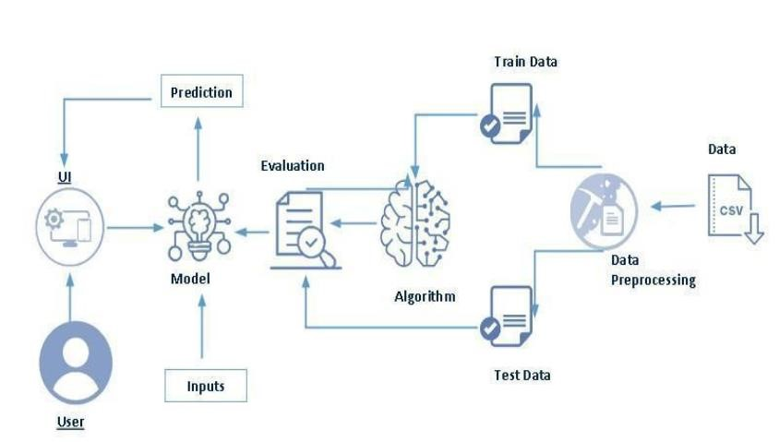

**3.2. SOFTWARE DESIGNING**

The following is the Software required to complete this project:

* **Google Colab**: Google Colab will serve as the development and execution environment for your predictive modeling, data preprocessing, and model training tasks. It provides a cloud-based Jupyter Notebook environment with access to Python libraries and hardware acceleration.
* **Dataset (CSV File)**: The dataset in CSV format is essential for training and testing your predictive model. It should include historical air quality data, weather information, pollutant levels, and other relevant features.
* **Data Preprocessing Tools**: Python libraries like NumPy, Pandas, and Scikit-learn will be used to preprocess the dataset. This includes handling missing data, feature scaling, and data cleaning.
* **Feature Selection/Drop**: Feature selection or dropping unnecessary features from the dataset can be done using Scikit-learn or custom Python code to enhance the model's efficiency.
* **Model Training Tools**: Machine learning libraries such as Scikit-learn, TensorFlow, will be used to develop, train, and fine-tune the predictive model. Regression or classification models can be considered, depending on the nature of the HDI prediction task.
* **Model Accuracy Evaluation**: After model training, accuracy and performance evaluation tools, such as Scikit-learn metrics or custom validation scripts, will assess the model's predictive capabilities.
* **UI Based on Flask Environment**: Flask, a Python web framework, will be used to develop the user interface (UI) for the system. The Flask application will provide a user-friendly platform for users to input location data or view HDI predictions, health information, and recommended precautions.
* Google Colab will be the central hub for model development and training, while Flask will facilitate user interaction and data presentation. The dataset, along with data preprocessing, will ensure the quality of the training data, and feature selection will optimize the model. Finally, model accuracy evaluation will confirm the system's predictive capabilities, allowing users to rely on the HDI predictions.

**5**

**.FLOWCHART**

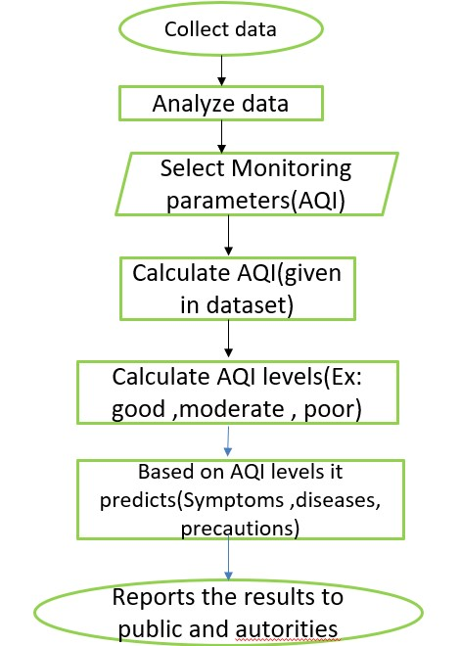

**USER INTERFACE**

**Input**

**Output**

**5.RESULT**

**Executing app.py :**

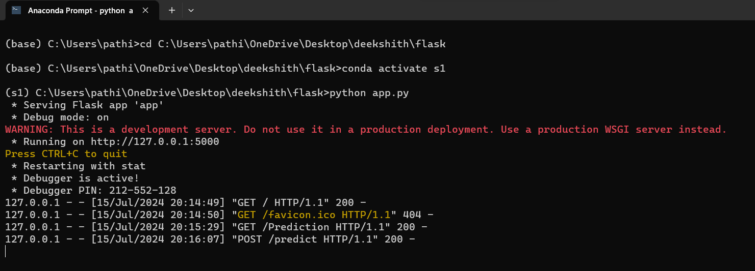

**HOME PAGE**

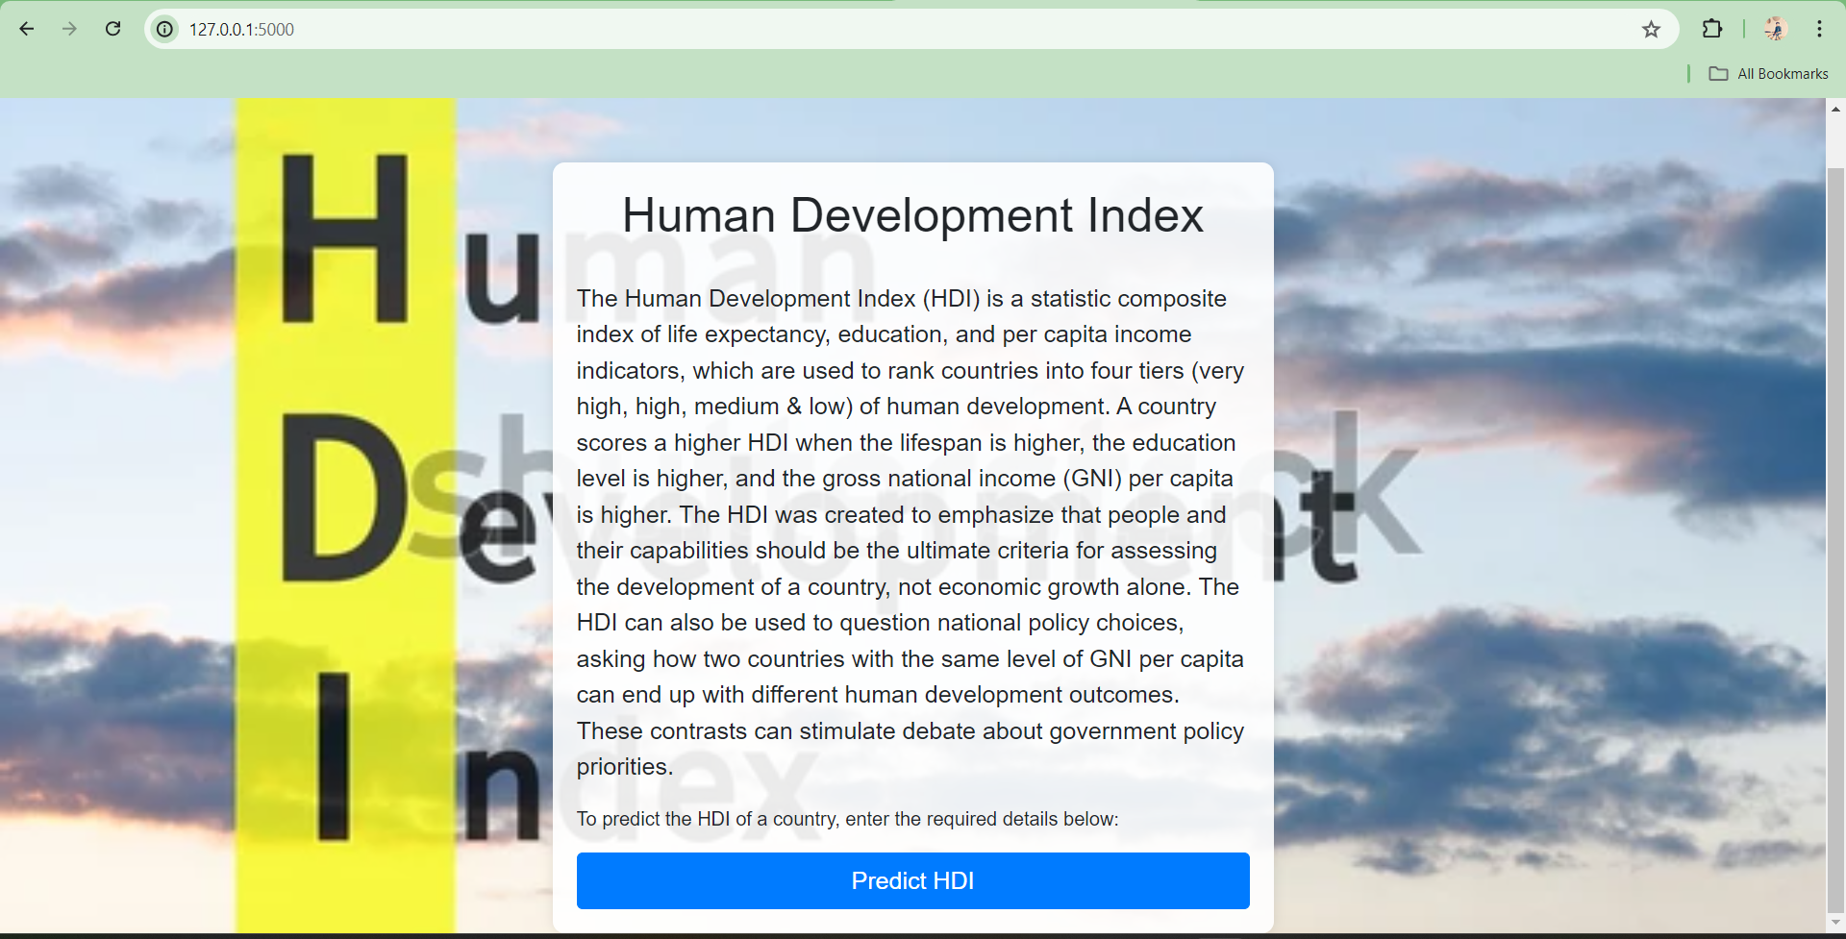

**INDEX PAGE**

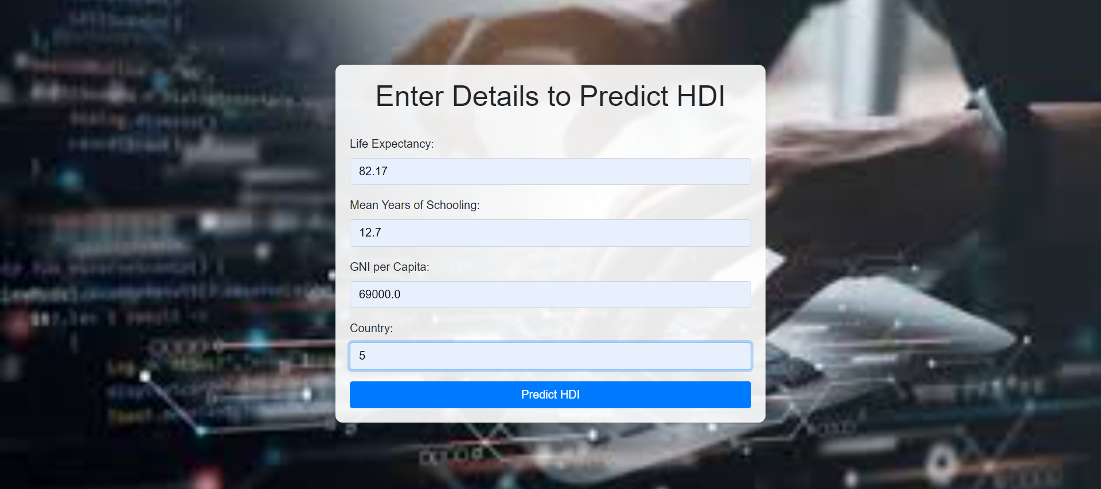

**PREDICTED PAGE**

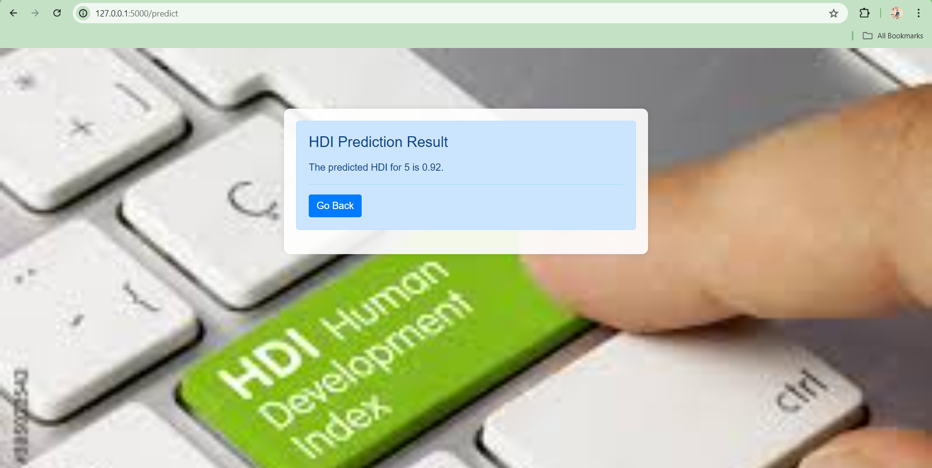

**7.ADVANTAGES AND DISADVANTAGES**

**ADVANTAGES:**

1. HDI measures three factors, rather than just income, giving a more rounded view of living standards than GDP.
2. Health, education and income are pivotal to good living standards
3. The data used is easy-­‐to-­‐obtain and reliable
4. Gives an idea about future living standards (i.e. education and life expectancy are indicators of the future situation)
5. The HDI is given as one number between 0 and 1, which allows for easy comparison between different countries.

**DISADVANTAGES:**

1. HDI gives no indication equality. Income and access to educational and health services might be high amongst a small group of people but low amongst others.
2. Years of schooling is unreliable if students are repeating years due to lack of progress. Also, going to school is worthless is the education is of a poor quality.
3. The calculation excludes outliers from the data, which is unfair because countries should be rewarded with higher HDIs for good performance in one particular field.
4. Adult literacy places too much emphasis on reading and writing-­‐ in this modern age computer literacy is arguably more important.

## 8.APPLICATIONS

1. **Policy Making**: Governments use the HDI to identify areas that needed improvement in health, education and income to enhance overall human development.
2. **Research and Analysis**: Researchers and academics use the HDI to study trends in human development over time and across different regions, providing valuable insights for policy recommendations.
3. **Global Ranking**: The HDI is used to rank countries based on their development levels, allowing for comparision and highlighting disparities that need attention.
4. **Sustainable Development Goals**: The HDI is used to track progress towards achieving the United Nation’s sustainable development goals, which aim to improve the quality of life for people around the world.

## 9.CONCLUSION

* In conclusion, the Human Development Index (HDI) serves as a pivotal tool in the global landscape of development measurement, offering a multifaceted view of human well-being that transcends mere economic metrics. By incorporating health, education, and income indicators, the HDI provides a comprehensive snapshot of development that is easy to understand and widely accepted. It guides policymakers, informs international comparisons, and raises public awareness about the crucial dimensions of human development.
* while the HDI is an invaluable tool for assessing and promoting human development, ongoing efforts to expand and improve its methodology are essential. These improvements will ensure that the HDI continues to serve as a reliable and comprehensive measure, driving policies and actions that enhance the quality of life and well-being for people worldwide.

**10.FUTURE SCOPE**

Future Scope of the A COMPREHENSIVE MEASURE OF WELL-BEING: A HUMAN DEVELOPMENT INDEX are:

1. **Environmental Sustainability**: Integrate indicators related to environmental health and sustainability, such as carbon emissions, air and water quality, and resource use.
2. **Multidimensional Poverty Index (MPI**): Complement the HDI with MPI to capture the broader spectrum of poverty and inequality..
3. **Income Distribution Metrics:** Incorporate measures like the Gini coefficient or Palma ratio to reflect income inequality.
4. **Alignment with SDGs**: Ensure the HDI is aligned with the United Nations Sustainable Development Goals, providing a comprehensive framework for measuring progress toward these goals.

**11.BIBILOGRAPHY**

1. Anderson H. R., R.W. Atkinson, J. L. Peacock, M. J. Sweeting and L. Marston. Ambient Particulate matter and health effect; Publication bias in studies of short-term association. Epidemiol16; 2005: 155163.
2. Analitis A.K. Katsouyanni, E. Dimakopoulou, A. K. Samoli,Y.Nikolouopoulos, G. Petasakis, J.

Touloumi, H. Schwartz, H. R.Anderson, K. Cambra, F. Forastiere, D. Zmirou, J. M. Vonk,L.clancy, B. Kriz, J. Bobvos and J. Pekkanen. Short-term effects of ambient paricles on cardiovascular and resipiratory mortilaity.

Epidemiol 17; 2006: 230-233.

1. Kumar A.,Goyal P. Forecasting of air quality in delhi using principal componemt regression technique. Atmospheric Pollution Research. 2 . 2011: 436-444.
2. Central Pollution Control Board (CPCB).Guidelines for National ambient air quality monitoring, Series: NAAQM/25/2003-04.Parivesh Bhavan,Delhi; 2009:
3. Central pollution control board (CPCB). National air quality index , Series CUPS/82/2014-15; 2014: [6] Ekpenyong E. C.,Eltebong E. O., Akpan E. E., Samson T. K.,Danierl E. N. Urban city transportation mode and respiratory health effect of an air pollution: a cross sectional study among transit and non transit worker in Nigeria. BMJ open,doi:10.1136/bmjopen-2012-001253; 2012:
4. Kaushik. C. P., Ravindra K., Yadav K., Mehta S. and Haritash A.K.. Assessment of ambient air quality in urban centres of haryana(india) in relation to different anthropogenic activities and health risks. Environment Monitoring and Assement. 122; 2006:27-40.
5. Pipalatkar. P. P. , Gajghate. D.G and Khaparde V.V. Source identification of different size fraction of PM10 Using Factor analysis at residential cum commercial Area of Nagpur city. Bull.Envionment Contam Toxicol. 88;2012: 260-264.
6. Pope C. A. III and D. W.Dockery Health effects of fine particulate air pollution; lines that connect. Journal of Air and Waste Management Association. 56; 2006: 709-742.
7. Bhuyan P. K.,Samantray P., Rout S. P. Ambient air quality status in choudwar area of cuttack district.International Journal of Environmental Sciences. 1; 2010:
8. Ravikumar,P., Prakash, K.L. and Somashekar,R.K.. Air quality Indices to understand the ambient air quality in the vicity of dam site of different irrigation projects in karanataka state, india.International journal of science and nature. 5; 2014 : 531-541.
9. U. S. Environmental Protection Agency (USEPA). Guidelines for reporting of daily air quality- air quality index (AQI), Series EPA-454/B-06-001. Research Trangle Park , North carolina.2006

## 12.APPENDIX

**Model building :**

1)Dataset

2)Google Colab and VS code Application Building

* HTML file (home.html, indexnew.html, resultsnew.html, error.html )
* Models in pickle format

**SOURCE CODE:**

**Home.html :**

<!DOCTYPE html>

<html lang="en">

<head>

    <meta charset="UTF-8">

    <meta name="viewport" content="width=device-width, initial-scale=1.0">

    <title>HDI Predictor</title>

    <link href="https://stackpath.bootstrapcdn.com/bootstrap/4.5.2/css/bootstrap.min.css" rel="stylesheet">

    <style>

        body {

            font-family: Arial, sans-serif;

            background-image: url('https://www.shutterstock.com/image-illustration/acronym-hdi-human-development-index-600w-339214301.jpg'); /* Replace with your background image URL */

            background-size: cover;

            background-position: center;

            background-repeat: no-repeat;

            background-attachment: fixed;

        }

        .container {

            max-width: 600px;

            margin-top: 100px;

            background-color: rgba(255, 255, 255, 0.9);

            padding: 20px;

            border-radius: 10px;

            box-shadow: 0px 0px 10px rgba(0, 0, 0, 0.1);

        }

        h1 {

            text-align: center;

            margin-bottom: 30px;

        }

        .btn-primary {

            background-color: #007bff;

            border-color: #007bff;

        }

        .btn-primary:hover {

            background-color: #0069d9;

            border-color: #0062cc;

        }

    </style>

</head>

<body>

    <div class="container">

        <h1 class="text-center">Human Development Index</h1>

        <p class="lead">The Human Development Index (HDI) is a statistic composite index of life expectancy, education, and per capita income indicators, which are used to rank countries into four tiers (very high, high, medium & low) of human development. A country scores a higher HDI when the lifespan is higher, the education level is higher, and the gross national income (GNI) per capita is higher. The HDI was created to emphasize that people and their capabilities should be the ultimate criteria for assessing the development of a country, not economic growth alone. The HDI can also be used to question national policy choices, asking how two countries with the same level of GNI per capita can end up with different human development outcomes. These contrasts can stimulate debate about government policy priorities.</p>

        <p>To predict the HDI of a country, enter the required details below:</p>

        <a href="/Prediction" class="btn btn-primary btn-lg btn-block">Predict HDI</a>

    </div>

    <script src="https://code.jquery.com/jquery-3.5.1.slim.min.js"></script>

    <script src="https://cdn.jsdelivr.net/npm/@popperjs/core@2.9.2/dist/umd/popper.min.js"></script>

    <script src="https://stackpath.bootstrapcdn.com/bootstrap/4.5.2/js/bootstrap.min.js"></script>

</body>

</html>

**Indexnew.html :**

<!DOCTYPE html>

<html lang="en">

<head>

    <meta charset="UTF-8">

    <meta name="viewport" content="width=device-width, initial-scale=1.0">

    <title>Predict HDI</title>

    <link href="https://stackpath.bootstrapcdn.com/bootstrap/4.5.2/css/bootstrap.min.css" rel="stylesheet">

    <style>

        body {

            font-family: Arial, sans-serif;

            background-image: url('https://encrypted-tbn0.gstatic.com/images?q=tbn:ANd9GcQovEiSw8rQFuFN29swsVJwnqY7ijwtzFenRw&s'); /* Replace with your background image URL */

            background-size: cover;

            background-position: center;

            background-repeat: no-repeat;

            background-attachment: fixed;

        }

        .container {

            max-width: 600px;

            margin-top: 100px;

            background-color: rgba(255, 255, 255, 0.9);

            padding: 20px;

            border-radius: 10px;

            box-shadow: 0px 0px 10px rgba(0, 0, 0, 0.1);

        }

        h1 {

            text-align: center;

            margin-bottom: 30px;

        }

        .btn-primary {

            background-color: #007bff;

            border-color: #007bff;

        }

        .btn-primary:hover {

            background-color: #0069d9;

            border-color: #0062cc;

        }

    </style>

</head>

<body>

    <div class="container">

        <h1 class="text-center">Enter Details to Predict HDI</h1>

        <form action="/predict" method="post">

            <div class="form-group">

                <label for="lifeExpectancy">Life Expectancy:</label>

                <input type="text" class="form-control" id="lifeExpectancy" name="lifeExpectancy" required>

            </div>

            <div class="form-group">

                <label for="meanYearsOfSchooling">Mean Years of Schooling:</label>

                <input type="text" class="form-control" id="meanYearsOfSchooling" name="meanYearsOfSchooling" required>

            </div>

            <div class="form-group">

                <label for="gniPerCapita">GNI per Capita:</label>

                <input type="text" class="form-control" id="gniPerCapita" name="gniPerCapita" required>

            </div>

            <div class="form-group">

                <label for="Country">Country:</label>

                <input type="text" class="form-control" id="Country" name="Country" required>

            </div>

            <button type="submit" class="btn btn-primary btn-block">Predict HDI</button>

        </form>

    </div>

    <script src="https://code.jquery.com/jquery-3.5.1.slim.min.js"></script>

    <script src="https://cdn.jsdelivr.net/npm/@popperjs/core@2.9.2/dist/umd/popper.min.js"></script>

    <script src="https://stackpath.bootstrapcdn.com/bootstrap/4.5.2/js/bootstrap.min.js"></script>

</body>

</html>

**Resultsnew.html :**

<!DOCTYPE html>

<html lang="en">

<head>

    <meta charset="UTF-8">

    <meta name="viewport" content="width=device-width, initial-scale=1.0">

    <title>HDI Prediction Result</title>

    <link href="https://stackpath.bootstrapcdn.com/bootstrap/4.5.2/css/bootstrap.min.css" rel="stylesheet">

    <style>

        body {

            font-family: Arial, sans-serif;

            background-image: url('https://encrypted-tbn0.gstatic.com/images?q=tbn:ANd9GcQBMIjFsUmh0OrHkc46bnMI4SjdiGzioej5bQ&s'); /* Replace with your background image URL */

            background-size: cover;

            background-position: center;

            background-repeat: no-repeat;

            background-attachment: fixed;

        }

        .container {

            max-width: 600px;

            margin-top: 100px;

            background-color: rgba(255, 255, 255, 0.9);

            padding: 20px;

            border-radius: 10px;

            box-shadow: 0px 0px 10px rgba(0, 0, 0, 0.1);

        }

        .alert {

            background-color: #cce5ff;

            color: #004085;

            border-color: #b8daff;

            margin-bottom: 20px;

            padding: 20px;

            border-radius: 5px;

        }

        h4 {

            margin-bottom: 15px;

        }

        .btn-primary {

            background-color: #007bff;

            border-color: #007bff;

        }

        .btn-primary:hover {

            background-color: #0069d9;

            border-color: #0062cc;

        }

    </style>

</head>

<body>

    <div class="container">

        <div class="alert alert-info" role="alert">

            <h4 class="alert-heading">HDI Prediction Result</h4>

            <p>{{ prediction_text }}</p>

            <hr>

            <a href="/home" class="btn btn-primary">Go Back</a>

        </div>

    </div>

    <script src="https://code.jquery.com/jquery-3.5.1.slim.min.js"></script>

    <script src="https://cdn.jsdelivr.net/npm/@popperjs/core@2.9.2/dist/umd/popper.min.js"></script>

    <script src="https://stackpath.bootstrapcdn.com/bootstrap/4.5.2/js/bootstrap.min.js"></script>

</body>

</html>

**Error.html :**

<!DOCTYPE html>

<html lang="en">

<head>

    <meta charset="UTF-8">

    <meta name="viewport" content="width=device-width, initial-scale=1.0">

    <title>Error</title>

    <style>

        body, html {

            height: 100%;

            margin: 0;

            font-family: Arial, sans-serif;

            text-align: center;

            background-image: url('background-image.jpg'); /* Replace with your background image */

            background-position: center;

            background-repeat: no-repeat;

            background-size: cover;

            display: flex;

            justify-content: center;

            align-items: center;

            color: white;

        }

        .container {

            background-color: rgba(0, 0, 0, 0.7); /* Dark overlay */

            padding: 40px;

            border-radius: 10px;

            width: 50%;

        }

        h1 {

            font-size: 2.5em;

            color: red;

            margin-bottom: 20px;

        }

        p {

            font-size: 1.2em;

            color: yellowgreen;

        }

    </style>

</head>

<body>

    <div class="container">

        <h1>Error</h1>

        <p>{{ error_text }}</p> <!-- Dynamic error message -->

    </div>

</body>

</html>

**App.py :**

from flask import Flask, render_template, request, redirect, url_for

import pickle

app = Flask(__name__)

# Load the model

with open('HDI.pkl', 'rb') as f:

    model = pickle.load(f)

@app.route('/')

@app.route('/home')

def home():

    return render_template('home.html')

@app.route('/Prediction')

def prediction():

    return render_template('indexnew.html')

@app.route('/predict', methods=['POST'])

def predict():

    try:

        # Retrieve form data

        life_expectancy = float(request.form['lifeExpectancy'])

        mean_years_of_schooling = float(request.form['meanYearsOfSchooling'])

        gni_per_capita = float(request.form['gniPerCapita'])

        country = request.form['Country']

        # Assuming the model requires these inputs in a specific order

        features = [life_expectancy, mean_years_of_schooling, gni_per_capita,country]

        # Make prediction

        prediction = model.predict([features])[0]

        prediction_text = f'The predicted HDI for {country} is {prediction:.2f}.'

        return render_template('resultsnew.html', prediction_text=prediction_text)

    except Exception as e:

        error_text = str(e)

        return render_template('error.html', error_text=error_text)

if __name__ == '__main__':

    app.run(debug=True)

## CODE SNIPPETS

### MODEL BUILDING :

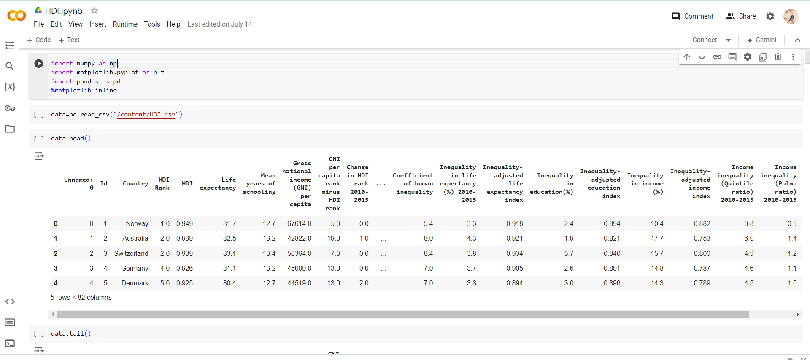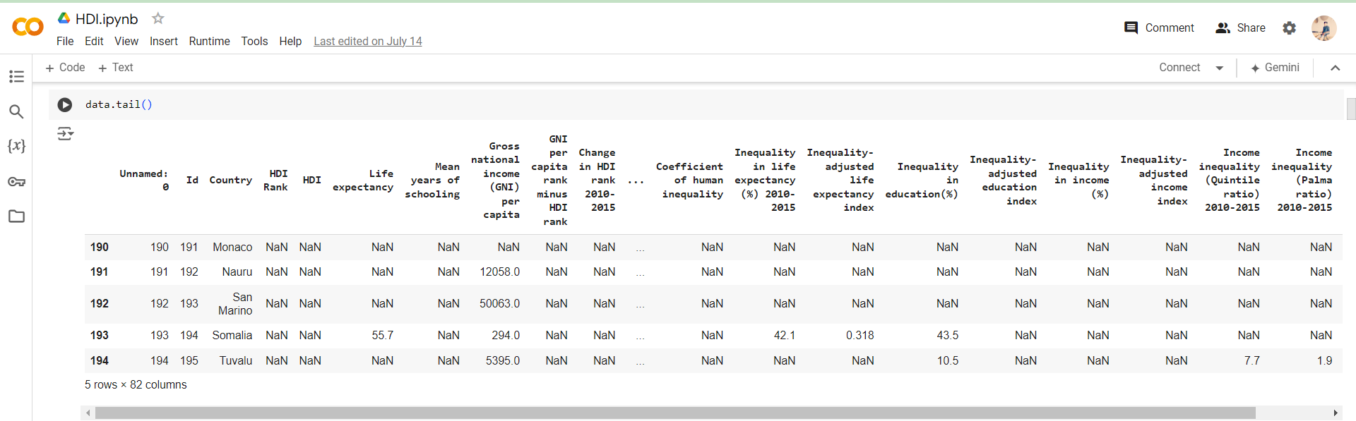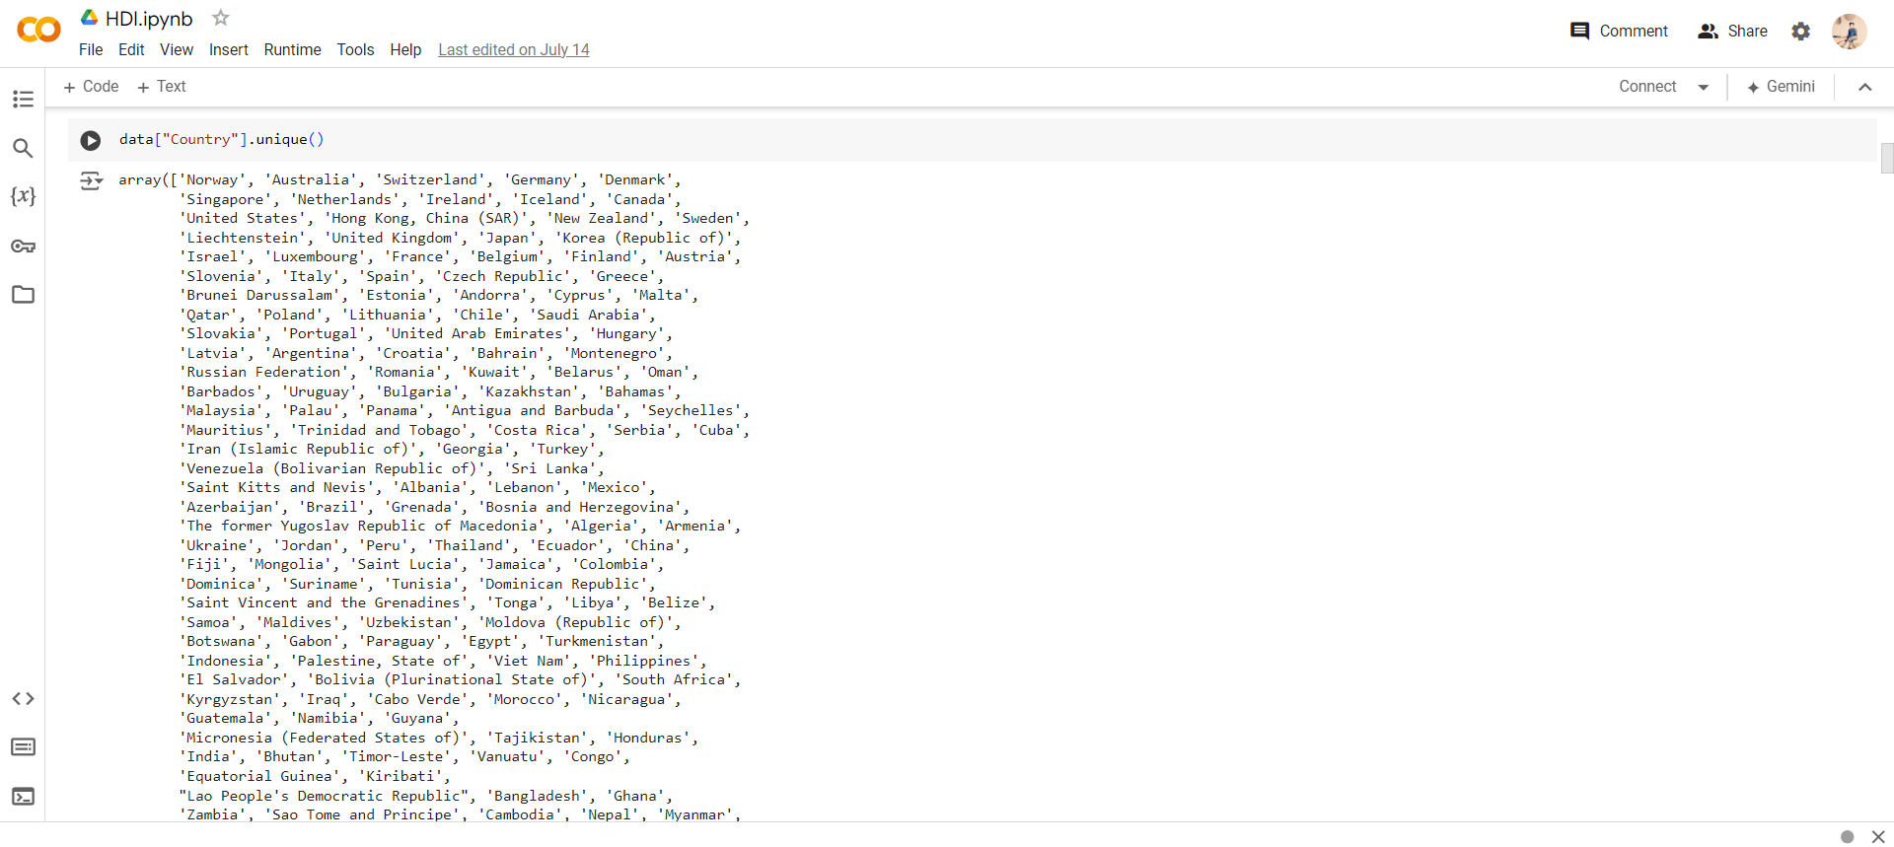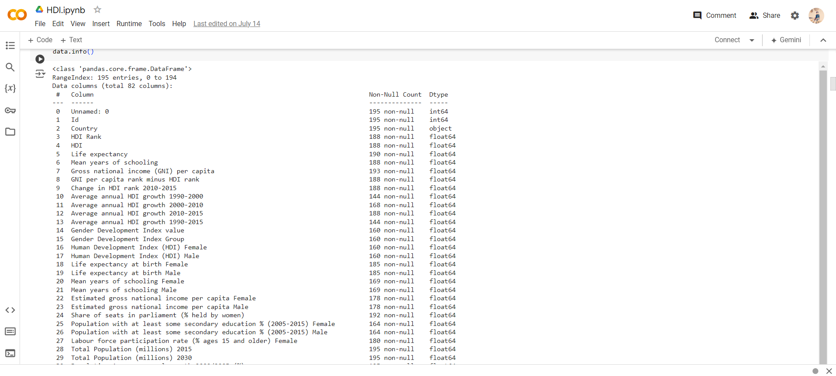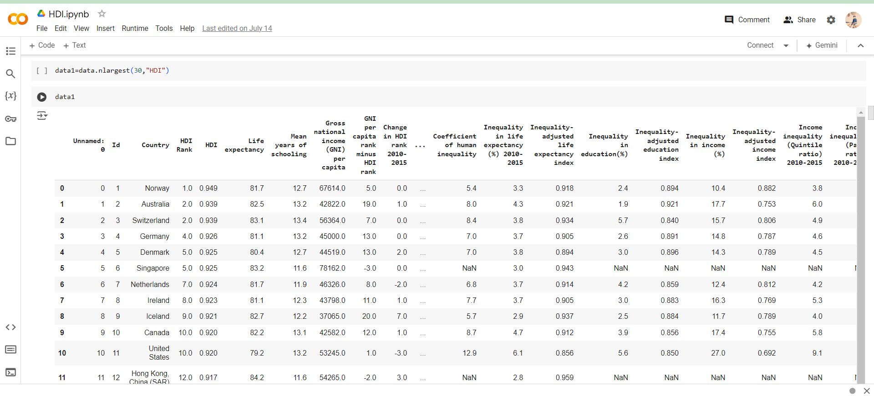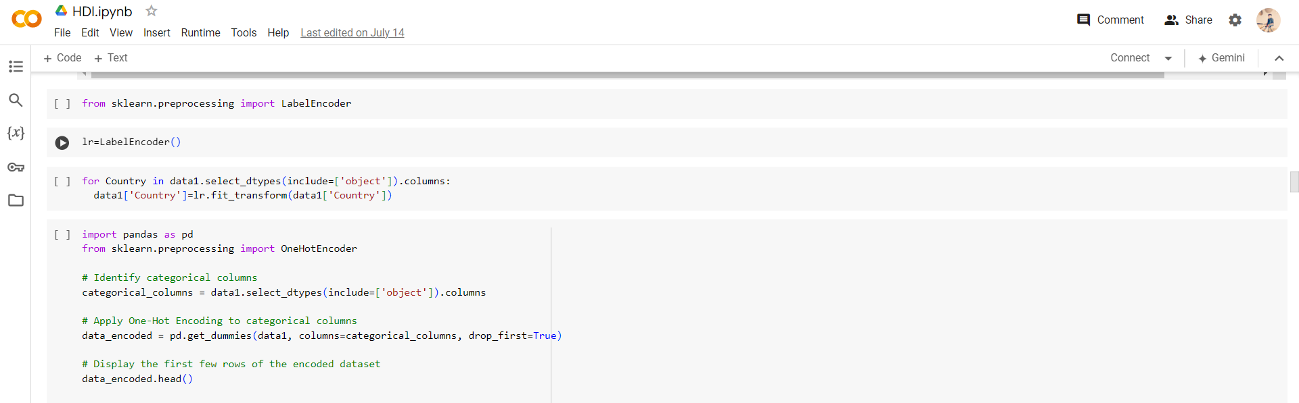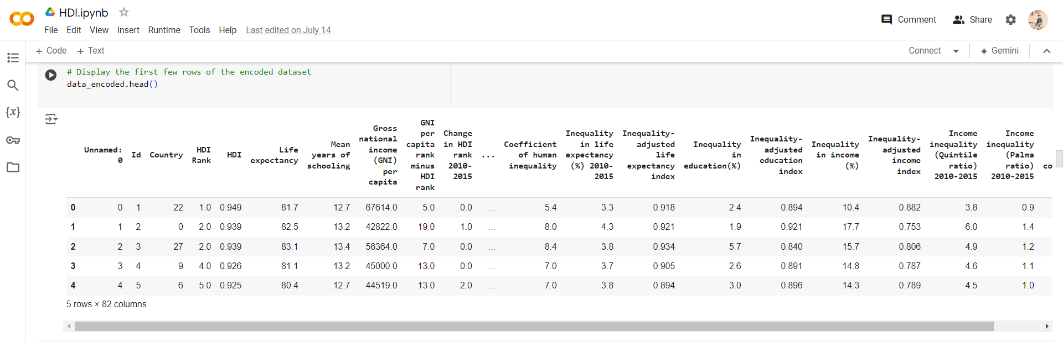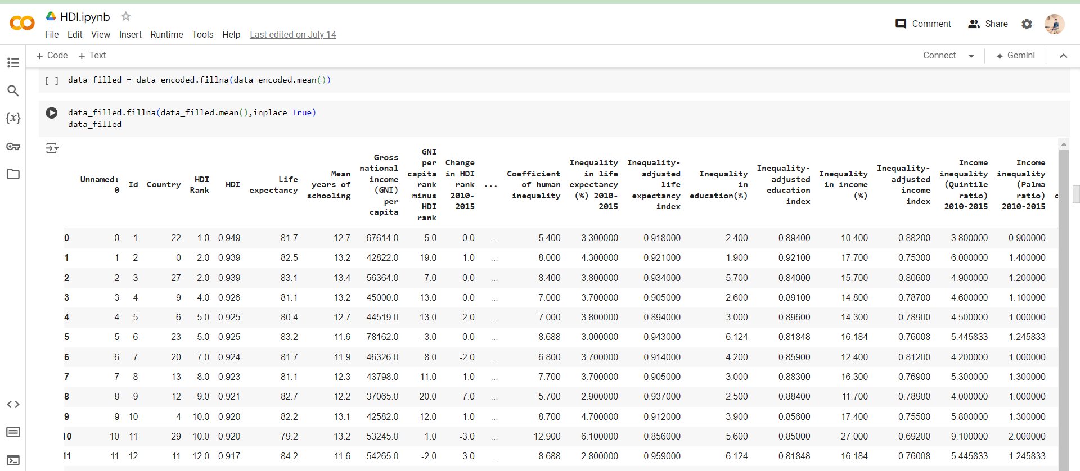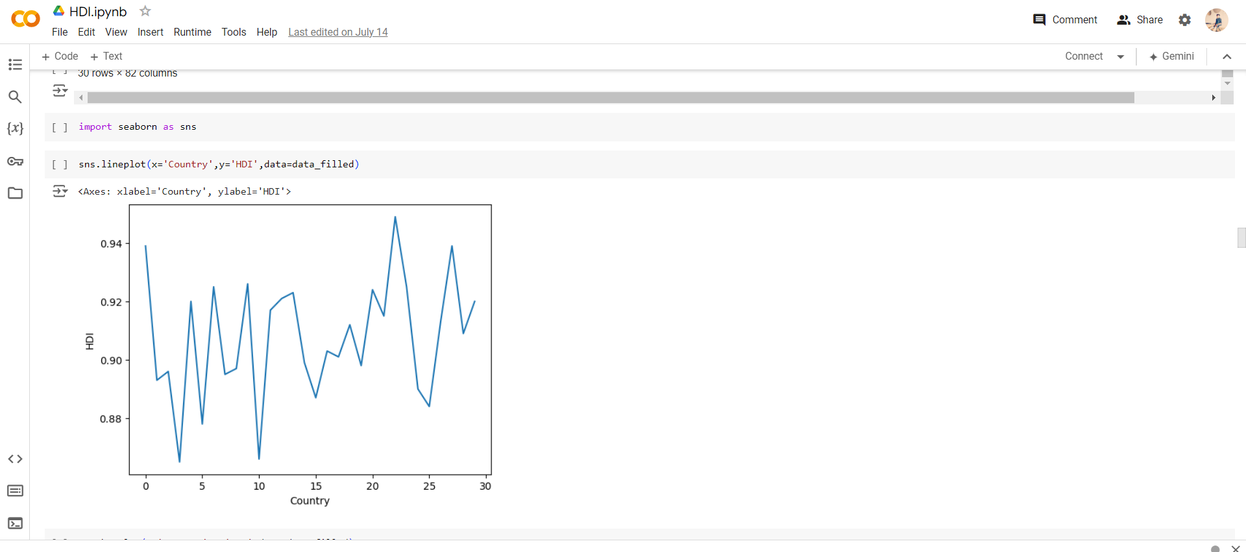

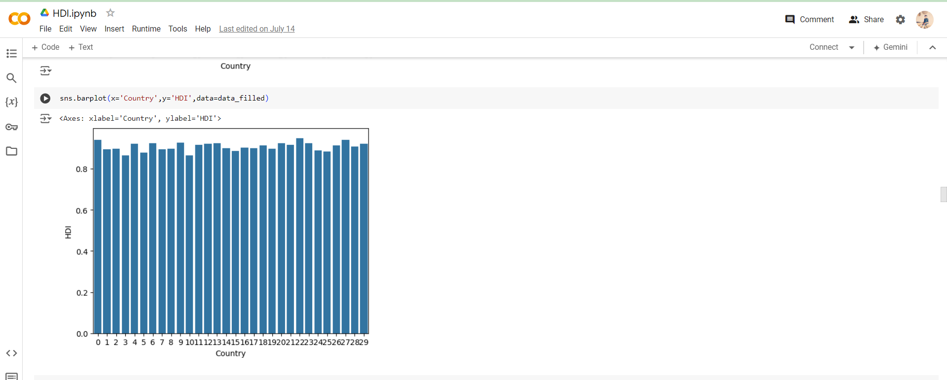

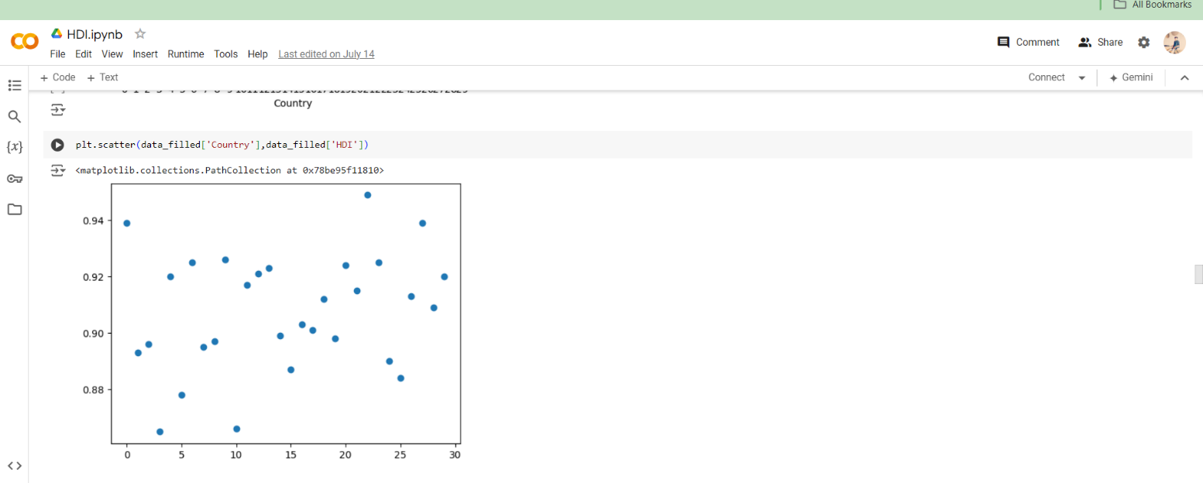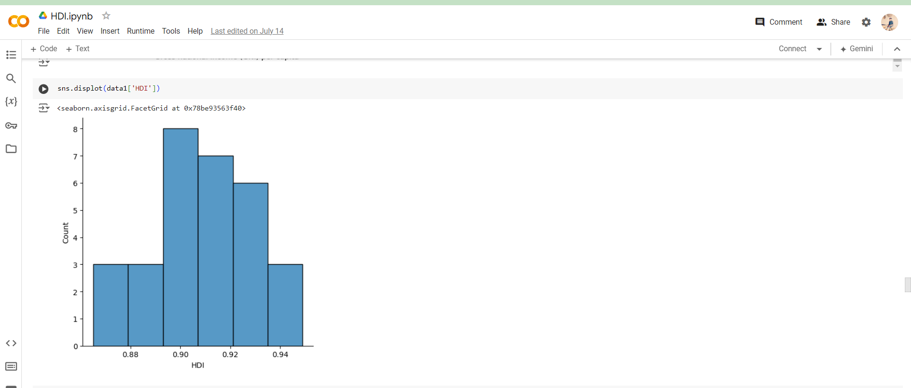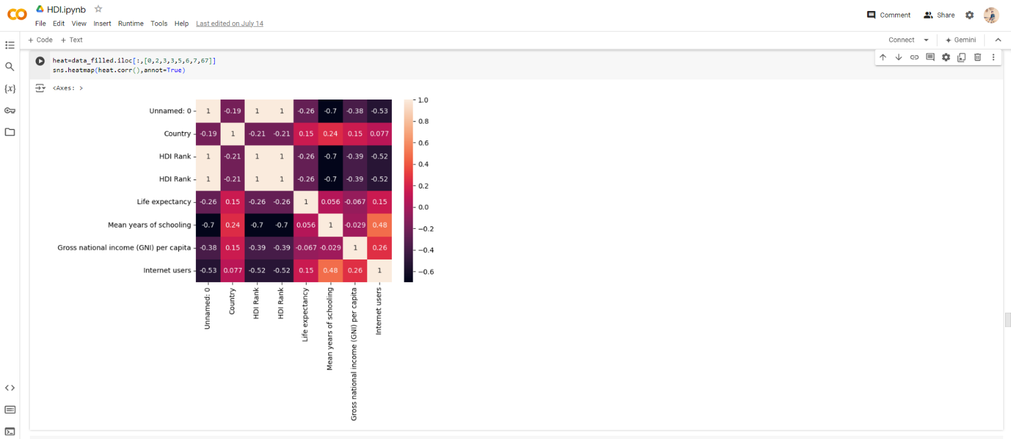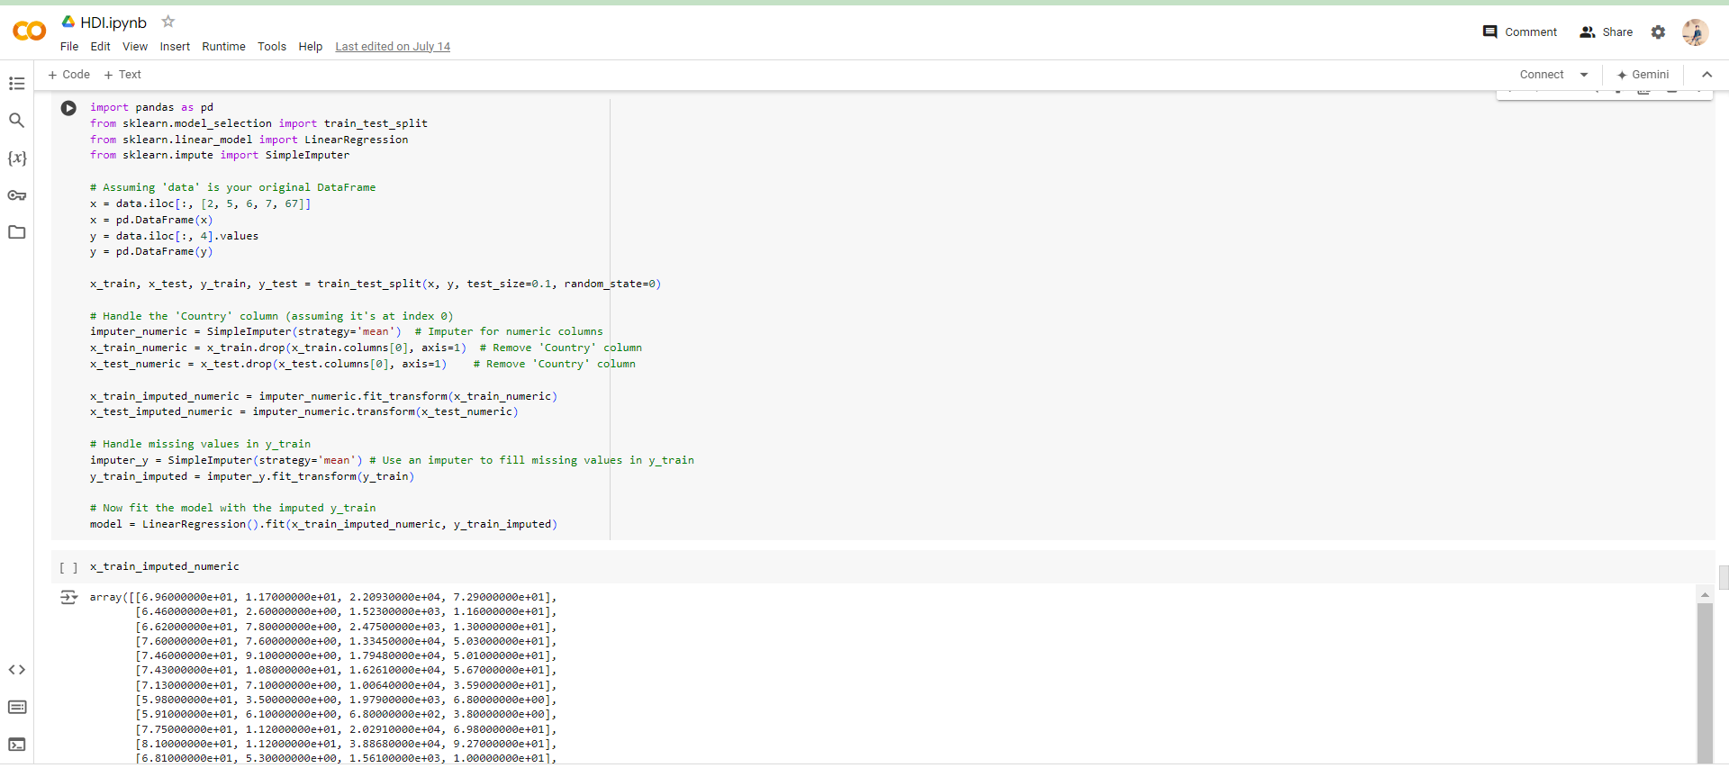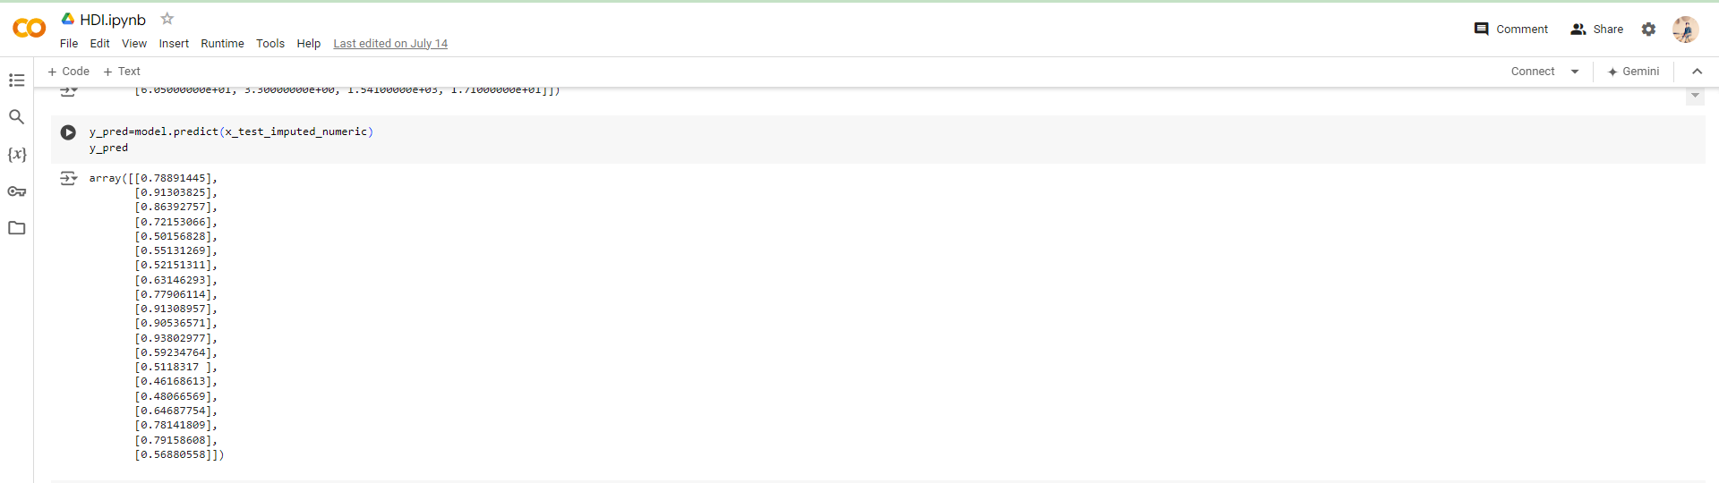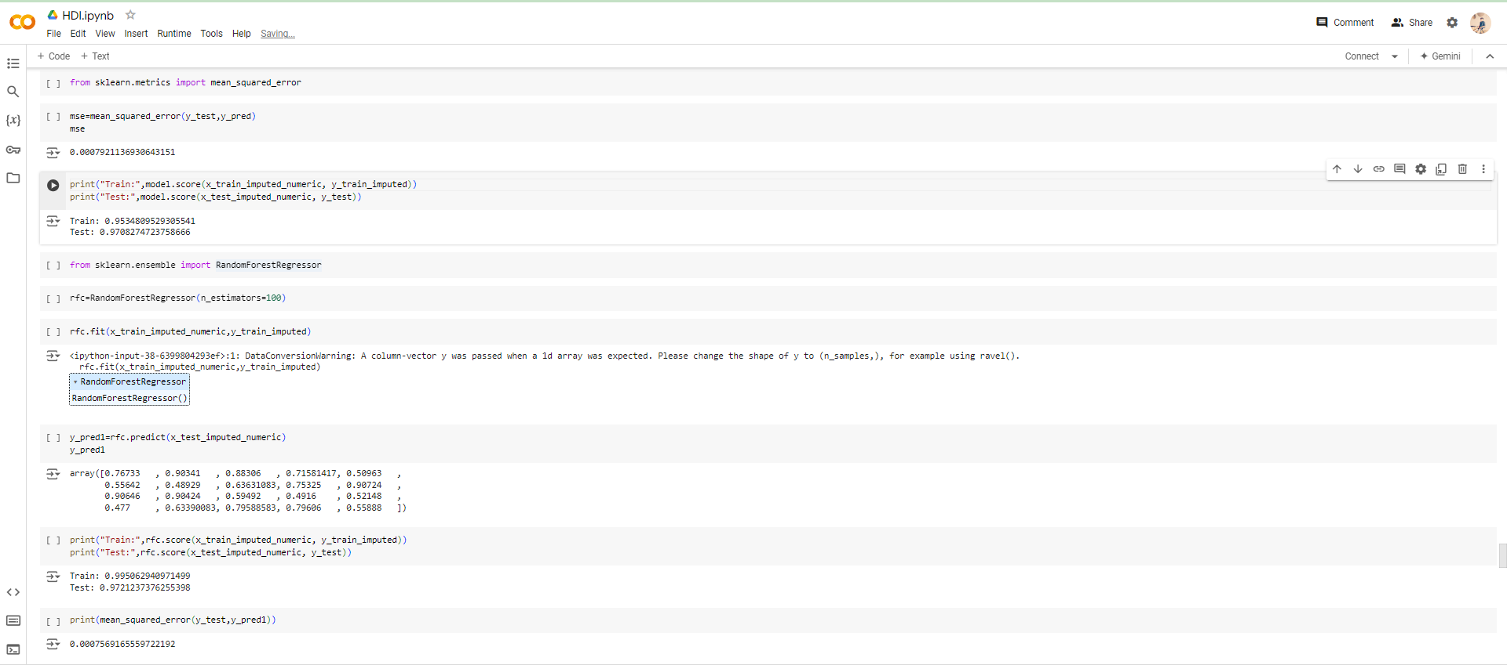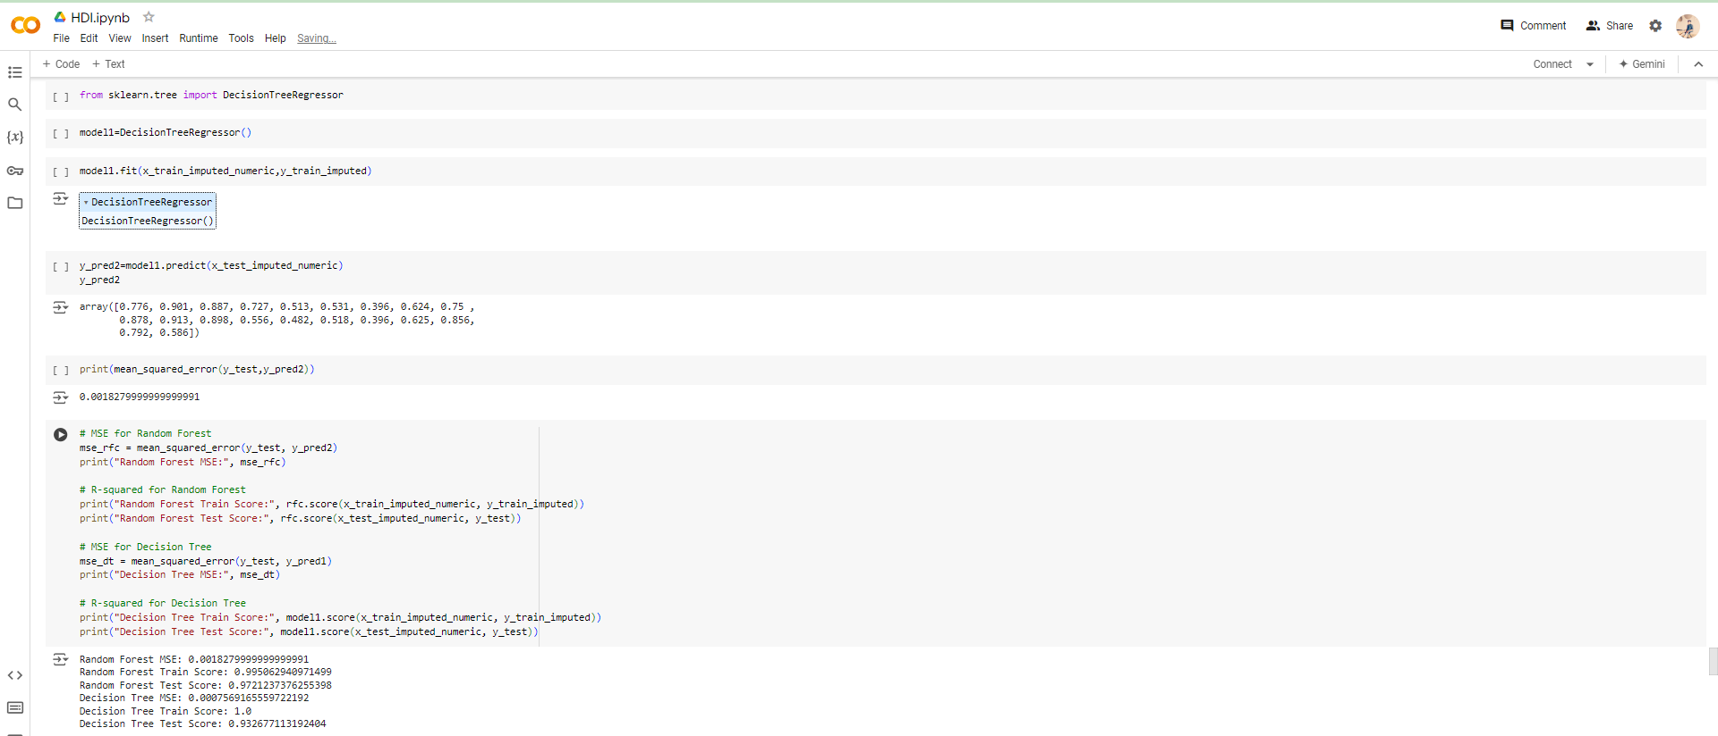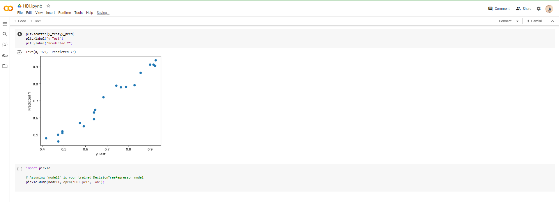

### PAIRPLOT

### HEAT MAP

### DESCRIPTIVE ANALYSIS